Name | Arsh Raina
UID no. | 2021600053
Experiment No. | 3

AIM: | Apply the concept of functions to incorporate modularity.
Program 1
PROBLEM STATEMENT : | // Write a function which takes a range as input. Print all the numbers in the range with ‘*’ in front of prime numbers only.
ALGORITHM: | Step 1: Declare function primeCheck(int x).  Step 2: In main declare variables start, end. Input and store their values.  Step 3: Run a for loop with variable i having values in range start to end.  Step 4: In each iteration, if primeCheck(i) returns 1, print i with a star. Else print i.  Step 5: In primeCheck function if x equals 1, return 0. Run a for loop with variable i having values in range 2 to x-1. In each iteration, if x modulus I is zero, return 0. Else return 1.
PROGRAM: | #include<stdio.h>  int primeCheck(int x);  int main(void) {  int start, end;  printf("Enter the start and end number separated by comma: ");  scanf("%d,%d",&start ,&end);  for(int i = start; i <= end; i++) {  if(primeCheck(i)) {  printf("%d*\t", i);  }  else {  if (i % 10 == 0){  printf("%d\n", i);  }  else{  printf("%d\t", i);  }  }  }  }  int primeCheck(int x) {  if(x == 1){  return 0;  }  for(int i = 2; i < x; i++) {  if(x % i == 0){  return 0;  }  }  return 1;  }
RESULT:

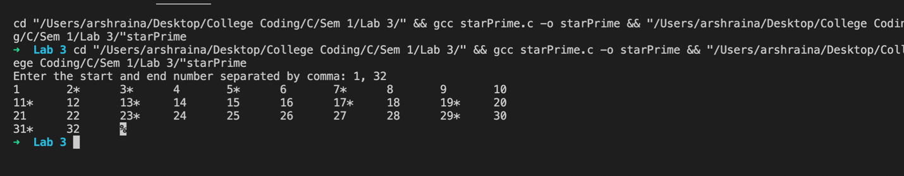

Program 2
PROBLEM STATEMENT : | // Write a function to find the sum of the proper divisors of a given number ‘n’.
ALGORITHM: | Step 1: Declare function divisorCheck(int x, int y).  Step 2: In main declare sum equals zero, n. Input and store val of n.  Step 3: Run a for loop with variable i having values in range 1 to n/2.  Step 4: In each iteration, if divisorCheck returns 1, increase the value of sum by i.  Step 5: Print sum.  Step 6: In divisorCheck function, if y modulus x equals zero, return 1. Else return 0.
FLOWCHART: | 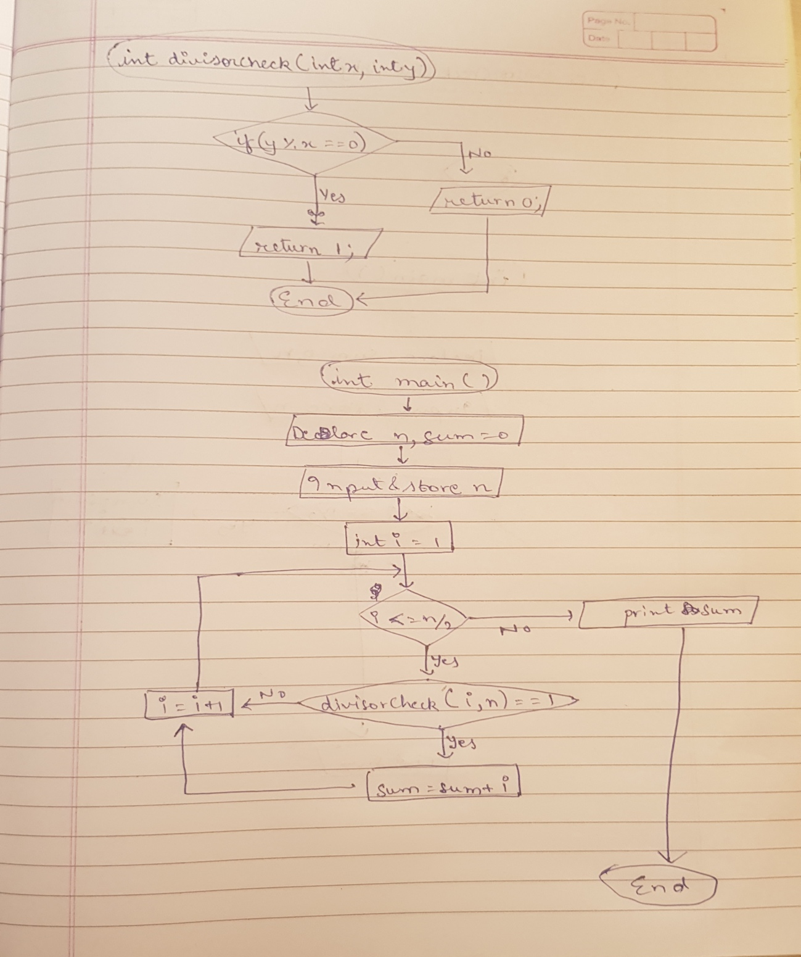
PROGRAM: | #include<stdio.h>  int divisorCheck(int x, int y);  int main(void) {  int sum = 0, n;  printf("Enter a number: ");  scanf("%d", &n);  for (int i = 1; i <= n/2; i++){  if(divisorCheck(i, n)) {  sum = sum + i;  }  }  printf("%d\n", sum);  }  int divisorCheck(int x, int y) {  if(y % x == 0) {  return 1;  }  return 0;  }
RESULT:
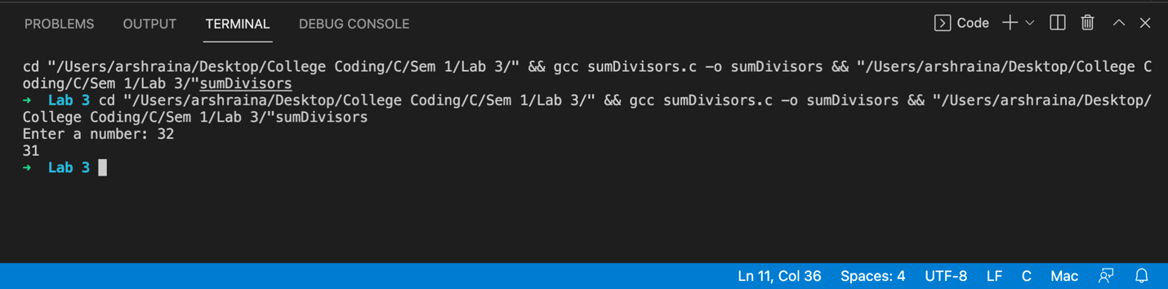
Program 3
PROBLEM STATEMENT: | // Write a function which takes as parameters two positive integers and returns TRUE if the numbers are amicable and FALSE otherwise.
ALGORITHM: | Step 1: Declare function divisorSum(int x).  Step 2: In main declare a, b. Input and store values of a and b.  Step 3: If a equals divisorSum(b) and b equals divisorSum(a), print TRUE. Else print FALSE  Step 4: In divisorSum function, declare variable sum = 0. Run a for loop with variable i having values in range 1 to x/2. In each iteration, if x modulus i equals zero, increase value of sum by i. Exit the loop and return sum.
PROGRAM: | #include<stdio.h>  int divisorSum(int x);  int main(void) {  int a,b;  printf("Enter two numbers separated by comma: ");  scanf("%d,%d",&a ,&b);  if (a == divisorSum(b) || b == divisorSum(a)) {  printf("TRUE\n");  }  else {  printf("FALSE\n");  }  }  int divisorSum(int x) {  int sum = 0;  for (int i = 0; i <= x/2; i++) {  if (x % i == 0) {  sum = sum + i;  }  }  return sum;  }
RESULT:
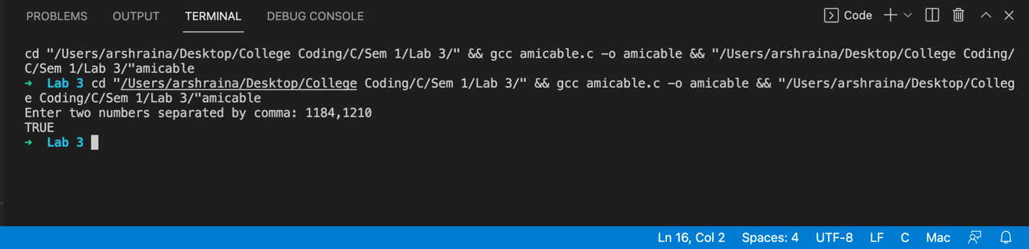
Program 4
PROBLEM STATEMENT: | // A common method of evaluating powers is merely to perform repeated  // multiplications. A more efficient method of evaluating XN is possible:  // Initialize PRODUCT to 1, POWER to X and M to N.  // While M is non-zero repeat the following task:  // If M is odd then  // Replace PRODUCT by PRODUCT * POWER  // End If;  // Replace M by M/2;  // Replace POWER by POWER * POWER  // End task.  // The required result is then in POWER.  // Write a function which represents this procedure for calculating XN.
ALGORITHM: | Step 1: Declare function xn(int x, int n).  Step 2: In main declare variables num, power. Input and store values of power and num.  Step 3: If num equals zero and power equals zero, print Undefined. Else print xn(num, power).  Step 4: In xn function, declare variable product = 1, power = x, m = n.  Step 5: In xn, run a while loop with condition m not equals zero. In each iteration, if m modulus 2 not equals zero, change product value to product multiplied by power.  Step 6: in the loop change value of m to m/2 and value of power to power multiplied by power.  Step 7: Exit the loop and return product.
PROGRAM: | #include<stdio.h>  int xn(int x, int n);  int main(void) {  int num, power;  printf("Enter power and number separated by comma: ");  scanf("%d,%d", &power, &num);  if (num == 0 || power == 0) {  printf("Undefined");  }  else {  printf("x^n: %d\n", xn(num, power));  }  }  int xn(int x, int n) {  int product = 1;  int power = x;  int m = n;  while (m != 0) {  if (m % 2 != 0) {  product = product * power;  }  m = m/2;  power = power * power;  }  return product;  }
RESULT:
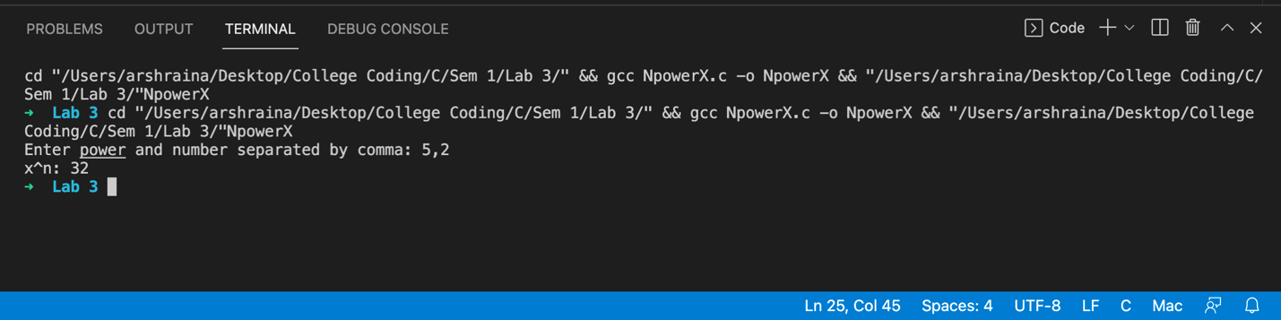
CONCLUSION: | Successfully applied the concept of functions to incorporate modularity.

